Q.Write a GUI application using which we can open,save,modify a text file (use MDIform for that )

Solution:

Imports System.IO

Public Class texteditorwithmdiform

Private Sub OpenToolStripMenuItem_Click(sender As System.Object, e As System.EventArgs) Handles OpenToolStripMenuItem.Click

Dim ofd As New OpenFileDialog

Dim filename As String

texteditorwithmdichildform.MdiParent = Me

ofd.ShowDialog()

filename = ofd.FileName

Dim fin As New StreamReader(filename)

texteditorwithmdichildform.RichTextBox1.Text = fin.ReadToEnd

texteditorwithmdichildform.Show()

fin.Close()

End Sub

Private Sub SaveToolStripMenuItem_Click(sender As System.Object, e As System.EventArgs) Handles SaveToolStripMenuItem.Click

Dim sfd As New SaveFileDialog

Dim filename As String

sfd.ShowDialog()

filename = sfd.FileName

Dim fout As New StreamWriter(filename)

fout.Write(texteditorwithmdichildform.RichTextBox1.Text)

fout.Close()

End Sub

End Class

Parent Form:

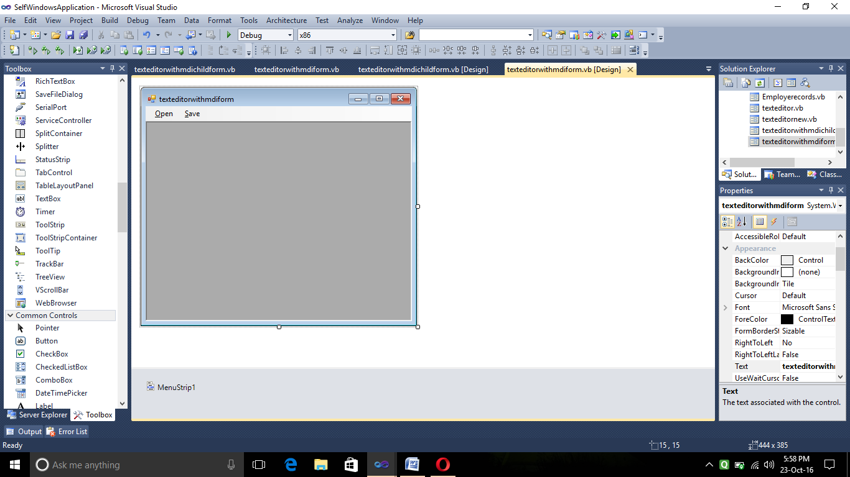

Child Form:

